California Department of Education  Executive Office  SBE-003 (REV. 09/2011)  dsib-iad-jan13item02 |  | ITEM #11
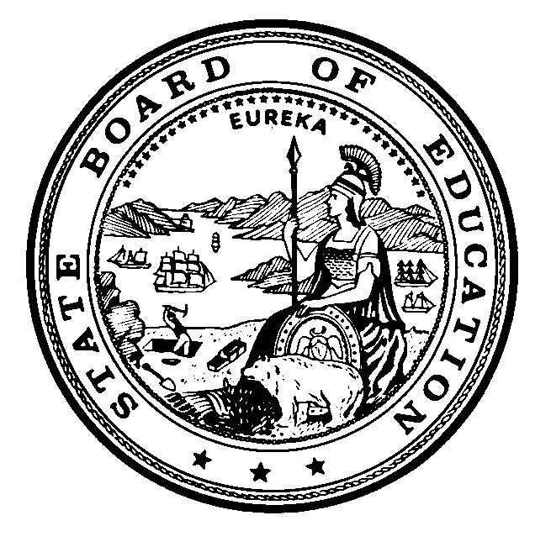 | CALIFORNIA STATE BOARD OF EDUCATION  JANUARY 2013 AGENDA
SUBJECT  Update on Issues Related to California’s Implementation of the Elementary and Secondary Education Act and Other Federal Programs. |  |  |  | Action
 |  |  |  | Information
 |  |  |  | Public Hearing

SUMMARY OF THE ISSUE(S)

This standing item allows the California Department of Education (CDE) to brief the State Board of Education (SBE) on timely topics related to the Elementary and Secondary Education Act (ESEA) and other federal programs.

RECOMMENDATION

The CDE recommends that the SBE take action as deemed necessary and appropriate. No specific action is recommended at this time.

BRIEF HISTORY OF KEY ISSUES

None

SUMMARY OF PREVIOUS STATE BOARD OF EDUCATION DISCUSSION AND ACTION

None.

FISCAL ANALYSIS (AS APPROPRIATE)

Any state or local educational agency (LEA) that does not abide by the mandates or provisions of the ESEA is at risk of losing federal funding.

ATTACHMENT(S)

None.

